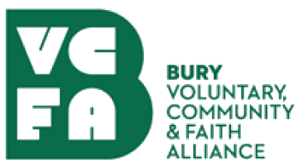 | Bury VCFA Trustee Nomination Form

Personal Information
Name:
Home address:
Contact telephone number:
Email address:
Name of VCSE group or organisation (if applicable):
Role in organisation:

Applying for this role
Tell us why you want to be a Trustee for Bury VCFA:

Tell us what skills, knowledge and experience you’ll bring to the Board (including any volunteering experience)

References
Please provide two referees for your suitability for the role (these can be personal or professional)
Referee 1
Name:
Address:
Phone number:
Email:
Relationship to you:

Referee 2
Name:
Address:
Phone number:
Email:
Relationship to you:

Nominee declaration
I declare that I am not disqualified from acting as a charity trustee and that:
- I am aged 18 years or over at the date of this election or appointment.
- I am capable of managing and administering my own affairs.
- I am not disqualified from acting as a charity trustee of any charity because of sections 178 to 180 of the Charities Act 2011 which includes:
  - anyone who has an unspent conviction for an offence involving deception or dishonesty;
  - anyone who is an undischarged bankrupt;
  - anyone who has been removed from trusteeship of a charity by the Court or the Charity Commission for misconduct or mismanagement;
  - anyone under a disqualification order under the Company Director Disqualification Act 1986;
  - anyone who has entered into a composition or arrangement with their creditors which includes an individual voluntary arrangement (IVA), and is currently on the Insolvency Service Register.
- I am not disqualified and/or barred from acting as a trustee.
- I undertake to fulfil my responsibilities and duties as a trustee of Bury VCFA in good faith and in accordance with the law and the objectives of the organisation.
- I do not have any financial interests in conflict with those of Bury VCFA (either in person or through family or business connections) except those that I have formally notified in a conflict of interest statement. I will specifically notify any such interest at any meeting where the Board of Trustees are required to make a decision which affects my personal interests, and I will, unless agreed otherwise, absent myself entirely from any decision on the matter and not vote on it.
- I promise to adhere to and promote the Bury VCFA Equal Opportunities policy.
- I will abide by the Code of Conduct for the Board of Trustees of Bury VCFA. (A full copy of the Code of Conduct is available on request).
- I certify I know of no other reason why I should be exempt from being a Trustee (Director) of Bury VCFA.

Signed:
Date:

Please return this form to admin@buryvcfa.org.uk by Monday, 27th October 2025

